Questions and Exercises to work out and turn in:

Grading Guidelines:

* A right answer will get full credit when:

1. It is right (worth 25%)
2. It is right **AND** neatly presented making it easy and pleasant to read. (worth an **extra** 15%)
3. There is an **obvious and clear link** between 1) the information provided in the exercise and in class and 2) the final answer. A clear link is built by properly writing, justifying, and documenting an answer (worth an **extra** 60%).
4. Calculation mistakes will be minimally penalized (2 to 5% of full credit) while errors on units will be more heavily penalized.

You are welcome/encouraged to discuss exercises with other students or the instructor. But, ultimately, **personal** writing is expected.

* USE THIS FILE AS THE STARTING DOCUMENT YOU WILL TURN IN. **DO NOT DELETE ANYTHING FROM THIS FILE:** JUST **INSERT** EACH ANSWER **RIGHT AFTER ITS QUESTION/PROMPT**.
* IF USING HAND WRITING (STRONGLY DISCOURAGED), **USE THIS FILE** BY CREATING SUFFICIENT SPACE AND WRITE IN YOUR ANSWERS.
* FAILING TO FOLLOW TURN IN DIRECTIONS /GUIDELINES WILL COST **A 30% PENALTY.**

Objectives of this assignment:

* to implement a pseudocode algorithm to collect data
* to check/validate a theoretical result.

What you need to do:

Complete the tasks described below.

Objective of this assignment:

* To verify empirically **Theorem 12.4** (Chapter 12, Textbook) that states:

“*The expected height h(n) of a randomly built binary search tree on n distinct keys is O(lg n).*”

What you need to do:

**Objective**:

The objective of this programming assignment is to verify empirically Theorem 12.4 that states that “*the expected height of a randomly built binary search tree on n distinct keys is O(lg n)*.”

In order to conduct this experiment, you must implement in your preferred language (available on Tux Machines) the Tree-Insert(T,z) operation. Below, I explain in pseudocode the program you must write to collect data and verify Theorem 12.4. You do not need to enforce that the keys are distinct.

**Program to implement**

collectData()

for n = 2,000 to 30,000 by 2,000 // 2,000, 4,000, 6,000, …. 30,000

sum_heightn = 0

for j = 1 to m do //Take m = 5 measurements mj

for i = 1 to n

pick randomly a number p in the range [0-15,000]

create a node z

set z.key = p

Tree-Insert(T,z)

Measure the height hj of the tree

Discard Tree (free memory)

sum_heightn += hj

collect Height(n)= sum_heightn/m // Average height for n

Write in a file F the value n and Height(n)in a csv format

1. (3 points) Implement the *Tree-Insert(T,z)* operation on a binary search tree.

Insert here the implementation of Tree-Insert method/procedure. You can use your preferred language as long as it is already installed on Tux machines.

1. (15 points) **Repeatedly** insert $n$ randomly picked numbers in a binary search tree and **collect** the height $h(n)$ of the obtained tree. $h(n)$ is the height of the binary search tree containing n elements. For simplicity, no need to enforce that the keys are distinct. In other words, you do not need to check whether a number is already in the tree.

a) Implement the program *collectData()* described below using pseudocode. You can use your preferred language as long as it is already installed on Tux machines. Turn in the source code of *collectData*() with this assignment file. Your program will be compiled, executed and tested on Tux machines.

b) Log onto a Tux machine, enter the command date, compile your *collectData*() program,

c) (5 points) Take a screenshot that clearly shows the date, your username, the tux machine name, the compilation directive and the program launch. The screenshot should be as readable as this template screenshot below. Credit for this assignment is conditioned on a readable screenshot that contains ALL required information (date, username, tux machine, compilation directives, program launch). In other words, if this screenshot is too small or missing, no credit will be awarded for this assignment. Insert the screenshot after the screenshot template below. 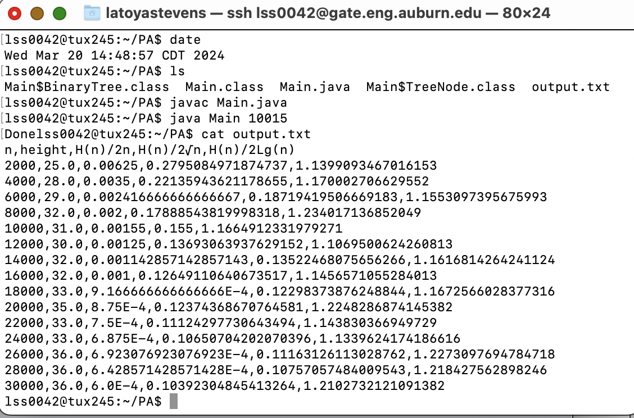

d) (10 points) Submit the csv (comma-separated-values) file F (See Pseudocode of *collectData*() )

1. (60 points = (20 points per function/plot))

a) (20 points) Plot here on the graph the plot function $\frac{h(n)}{2lg(n)}$ versus ***n***.

Insert the plot here

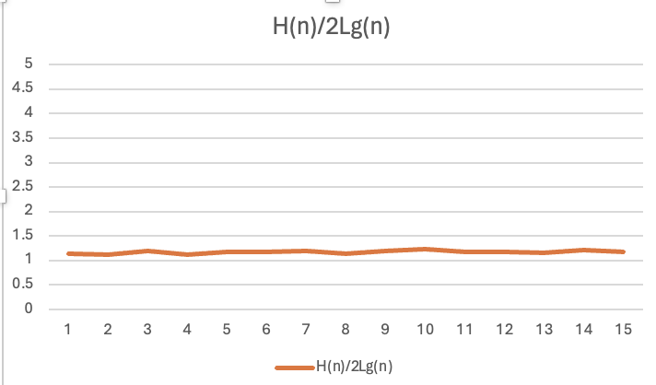

b) (20 points) Plot here on the graph the plot function $\frac{h(n)}{2\sqrt{n}}$ versus ***n***.

Insert the plot here

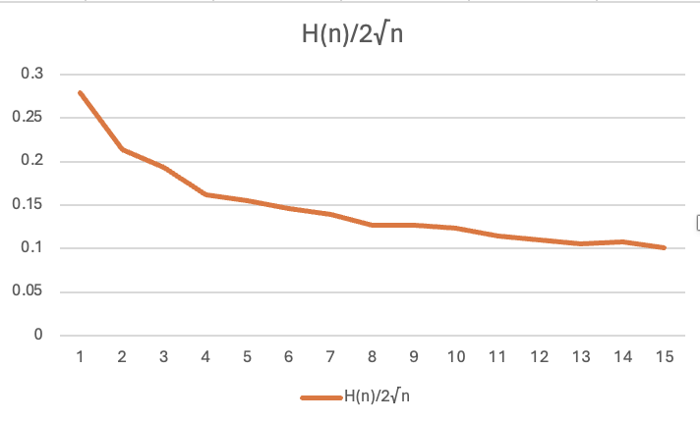

b) (20 points) Plot here on the graph the plot function $\frac{h(n)}{2n}$ versus ***n***.

Insert the plot here

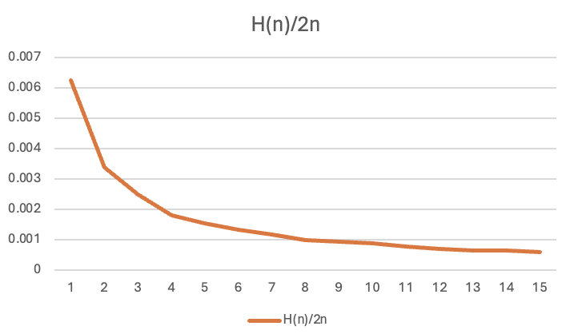

1. (22 points)

a) (4 points) Suppose that $h(n) ∈Θ(lg(n))$, what should be the expected expression and shape of $\frac{h(n)}{2lg(n)}$ when n tends to infinity?

Answer here ... (hint: if $h(n) ∈Θ(lg(n))$, then $h(n) ≈Klg(n)$ when n tends to infinity with K a constant)

The expression would be $\frac{h(n)}{2lg(n)}= \frac{k∙lg(n)}{2 ∙lg⁡(n)}= \frac{k}{2}$

If $h(n) ∈Θ(lg(n))$,then the height of the binary tree, h(n), and lg(n) increase at comparable logarithmic rates, modulated by some constant factor *k*. This relationship implies that the ratio *h*(*n*)/(2lg(*n*)) will effectively halve the constant *k*. So, as *n* grows, the expression will converge to a constant value, creating a graph with a horizontal line at *k*/2. This constancy visually captures the proportionate growth of the tree's height to the logarithm of its size.

b) (4 points) Suppose that $h(n) ∈Θ(lg(n))$, what should be the expected expression and shape of $\frac{h(n)}{2\sqrt{n}}$ when n tends to infinity?

Answer here ... The expression would be $\frac{k∙lg(n)}{2 ∙√n}$

If $h(n) ∈Θ(lg(n))$, then the height of the binary tree, h(n), would grow much slower than 2√n since it is proportional to lg(n). Due to this the expression above would trend toward zero as n gets larger. The expected shape of the graph would be a curve that gradually decreases toward zero, flattening out as n becomes very large. This decline reflects the slower growth rate of h(n) compared to 2√n.

c) (4 points) Suppose that $h(n) ∈Θ(lg(n))$, what should be the expected expression and shape of $\frac{h(n)}{2n}$ when n tends to infinity?

Answer here ... The expression would be $\frac{k∙lg(n)}{2 n}$

If $h(n) ∈Θ(lg(n))$, then the height of the binary tree, h(n), would grow much slower than 2n since it is proportional to lg(n). As n tends toward infinity, lg(n) grows logarithmically which is much slower than the linear growth of n. So the ratio should tend toward zero as n tends towards infinity. The expected shape of the graph would be a curve that would tend toward zero but flatten out for larger values of n. This graphs curve is much sharper for smaller values of n than the curve of 2√n because n grows faster than √n.

d) (10 points) Conclude about the validity of Theorem 12.4. Recall that this theorem states “*The expected height h(n) of a randomly built binary search tree on n distinct keys is O(lg n).*”

The observations for the graphs support the theorem, it states that the expected height h(n) of a randomly built BST with n distinct keys is $Θ(lg\left(n\right))$. The decreasing trends of $\frac{h(n)}{2n}$ and $\frac{h(n)}{2\sqrt{n}}$ towards zero along with the horizontal trend of $\frac{h(n)}{2lg(n)}$, confirms that h(n) grows logarithmically with n.

**Report**

* **Insert** your answers where indicated. This file with your inserted answers will **contain**, explain, and discuss the plots.
* In addition, the above report (this file) must contain the following information:
  + whether your data collection program works or not (this must be just ONE sentence)
  + the directions to compile and execute your program
* Good writing is expected.
* Recall that answers must be well written, documented, justified, and presented to get full credit.

**What you need to turn in:**

* Electronic copy of your source data collection program (separately attached to this assignment)
* Electronic copy of the csv file F
* Electronic copy of this file (including your inserted answers) (separately attached). Submit the file as a Microsoft Word or PDF file.

**Grading**

* See points distribution with questions/tasks.